# Session 1

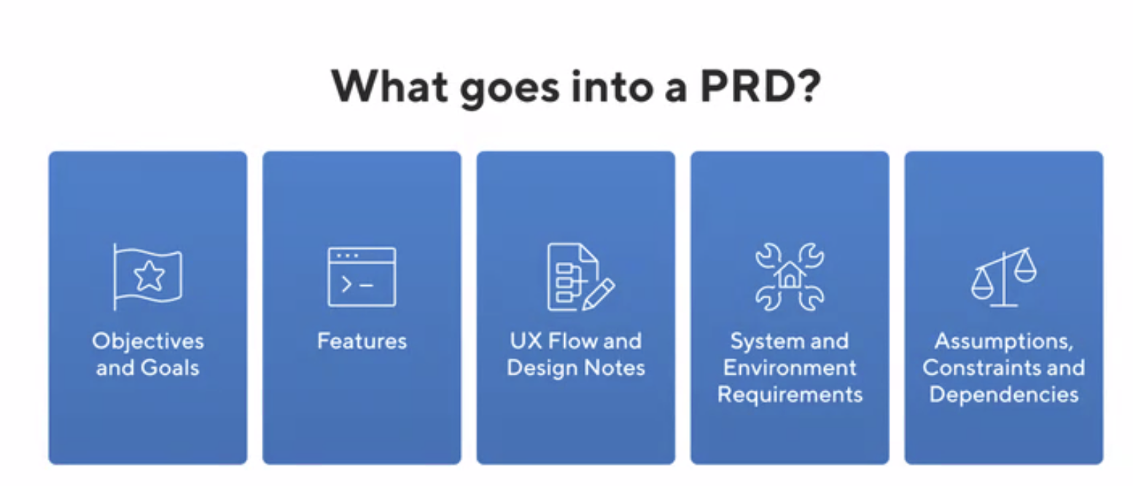

**Identify the right problem to solve:**

What is the real business need -> understanding needs (pain points, unmet demands)

**How to understand users:**  
- user interviews; stakeholder interviews, metrics, competitors, focus group, observations

**Problem definition:**

How might we + intend action verb + for + potential user + so that + desired outcome

Come up as many ideas as possible!

**Greg**: “As a next step that Milan will begin to discuss tomorrow morning (8am and 9am Workshops), **we recommend Figma**. Bubble is fine, yet has capabilities beyond what is necessary, has a much higher learning curve and can be buggy. You will only be asked to prototype. There will be no live demonstration in the presentation or ability to do so (no internet access). Visuals of your product will need to be included in the slides.”

**Greg**: “We would expect you to identify **a persona, use case and core features.** Better teams will mention what features will be excluded and why as less can be more.”

“For the competition, you will not submit a PRD. Yet, it allows you to structure your thinking and strongly deepen your analysis. So this foundational step is very important. While you will not submit a PRD document, you will likely show elements on your PRD document on your slides as you tell the story of your product development process to enhance your credibility.”

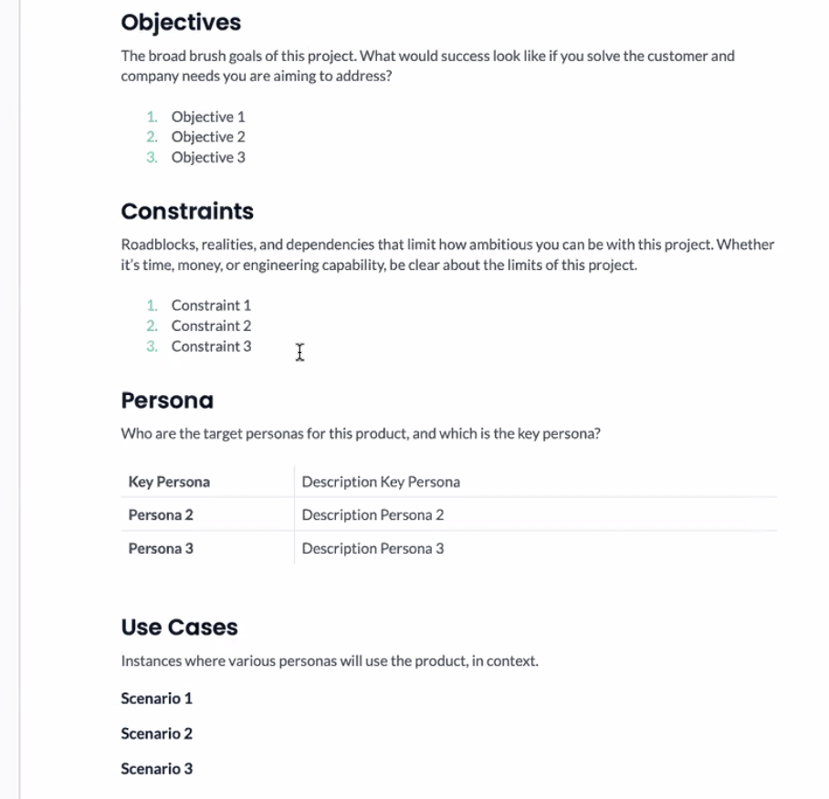

# Session 2 & 3

Design & Code

[Create dataset](https://huggingface.co/datasets/FronkonGames/steam-games-dataset)

Try [Figma make](https://www.figma.com/make/) rather than ppt

‘For the Case Competition you will provide a briefing of your ideas and work with images of your prototype. You will provide visuals yet not provide a live demonstration.’

**Case Competition Topics:**

#1 Product Design & Business Requirements

#2 Building an End-to-End data product;

#3 Designing a User Interface

Product Design & Business Requirements

* Start with product requirements as an evolving document
  + Prioritize user needs and business requirements
* Can you Figma as a group to identify key parts needed in our product design process
  + Break complex problem and product goal into smaller, simpler steps/units
  + Can create low and high fidelity prototypes
  + Brainstorm process, mind maps, mockups, rapid prototyping
  + Beta LLM AI tool in Figma for prototyping, mockups, etc
    - Will give output in HTML
    - Typical use cases: website and mobile app design
    - Can integrate Google Colab code i.e. web recommender system with the AI generated mockup design i.e. search page
      * Can prototype to load code and use in mockup version to test out on Figma
* Figma resources and recommendations
  + Lots of tutorials on the website
  + Recommended to use templates to start
  + Youtube tutorials
  + More so, best way to flush out mind maps and design thinking process and steps
* Free resources: Figma premium with ai tool for mockup generation
  + Use .[usc.edu](http://usc.edu) email → sign up and given free premium account for Figma
  + Figma+ Make

Building an End-to-End data product

* Building a data product
  + After design steps in figma, can vibe code if you understand the problem steps and coding steps needed to take in design process
  + Resources: Google Colab (LLM generator integrated), HuggingFace (like github for posting useful models that others have made)
    - For LLM generating code in Colab, make sure to have it generate step by step and not give a run of final code
      * Example use case: can integrate open AI API or other AI APIs, can set up a financial limit for API use; make sure open AI API name aligns with name given by LLM code generation
      * LLM code is messy, focus on functionality first and make code pretty later
  + When needed can use/switch to GPU T4 (more powerful) when trying to run LLM generated code in colab
    - CPU (primary) - few strong core units which acts as main processor to help hardware (i.e. phone, social media, email, computer etc.) run and process
      * Is limited for applications for neural nets, ML, LLMs, etc.
    - GPU - thousands of weaker processors
      * Used for graphics, video games, etc.
      * Processed in parallel by many weak units
      * Better for ML, AI applications
    - Consider running time -when okay and when too long
  + Example case:
    - 1) Want a recommendation system for games based on interest, that delivers a fun Open AI style summary
    - 2) Extract and embed keywords (embed - words identify based on meaning)
    - 3) Create a function to match search and embedded words to come up with results
    - 4) Use Open AI API to create fun summary for game matching results
    - 5) Call AI API function and test code